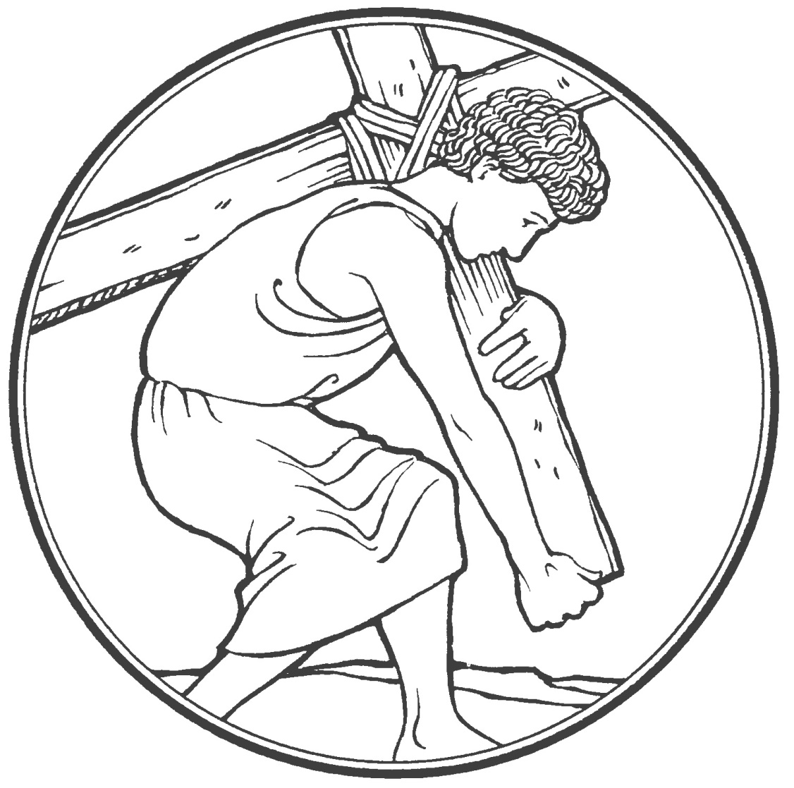
2nd Sunday in Lent
God is with you in your suffering and in your crosses
CHRIST LUTHERAN CHURCH | Lodi, California
February 28, 2021
WELCOME TO WORSHIP
Welcome to Christ Lutheran Church. We pray that your soul will be strengthened by the good news about God’s grace, love, and forgiveness given to us. If you would like to learn more about our church, please speak with our pastor or one of our members after the service.
- Bathrooms are located in the fellowship hall. A changing table is located in the women’s bathroom.
WORSHIP THEME
“Don’t make promises you can’t keep.” This old proverbial saying is a good one. If a person heeds it, they can avoid a heap of trouble! In today’s Old Testament Reading, God Himself makes a promise that seems impossible to keep. The Lord appears to a ninety-nine-year-old man and promises him descendants, and not just a few descendants, but that he will be the father of a multitude of nations. Thankfully, God never makes promises He can’t keep. Through the fulfillment of His promise to Abraham, the Lord ultimately provides a descendant by whom all nations would be blessed—Jesus Christ, the Son of Abraham, the Son of God. Through Him, God promises you forgiveness, life, and salvation—a promise that the Lord will keep!
We pray in the Lord’s Prayer, “Deliver us from evil.” We confess that God is our great protector against sin, death, and the devil. He proved His power to deliver us in the faithfulness of Jesus, who took on flesh and lived among us even though it would mean His death on the cross. Death does not turn Him away from you, and neither will sin or the devil himself. He is patient and enduring to the end, all for the sake of gathering you into His kingdom and keeping you safely there.

OPENING HYMN Chief of Sinners Though I Be | CW 385
INVOCATION
M: The grace of our Lord Jesus Christ and the love of God and the fellowship of the Holy Spirit be with you.
C: And also with you.

CONFESSION OF SINS
M: We have come into the presence of God, who created us to love and serve him as his dear children. But we have disobeyed him and deserve only his wrath and punishment. Therefore, let us confess our sins to him and plead for his mercy.
C: Merciful Father in heaven, I am altogether sinful from birth. In countless ways I have sinned against you and do not deserve to be called your child. But trusting in Jesus, my Savior, I pray: Have mercy on me according to your unfailing love. Cleanse me from my sin, and take away my guilt.
M: God, our heavenly Father, has forgiven all your sins. By the perfect life and innocent death of our Lord Jesus Christ, he has removed your guilt forever. You are his own dear child. May God give you strength to live according to his will.
C: Amen.
M: In the peace of forgiveness, let us praise the Lord.
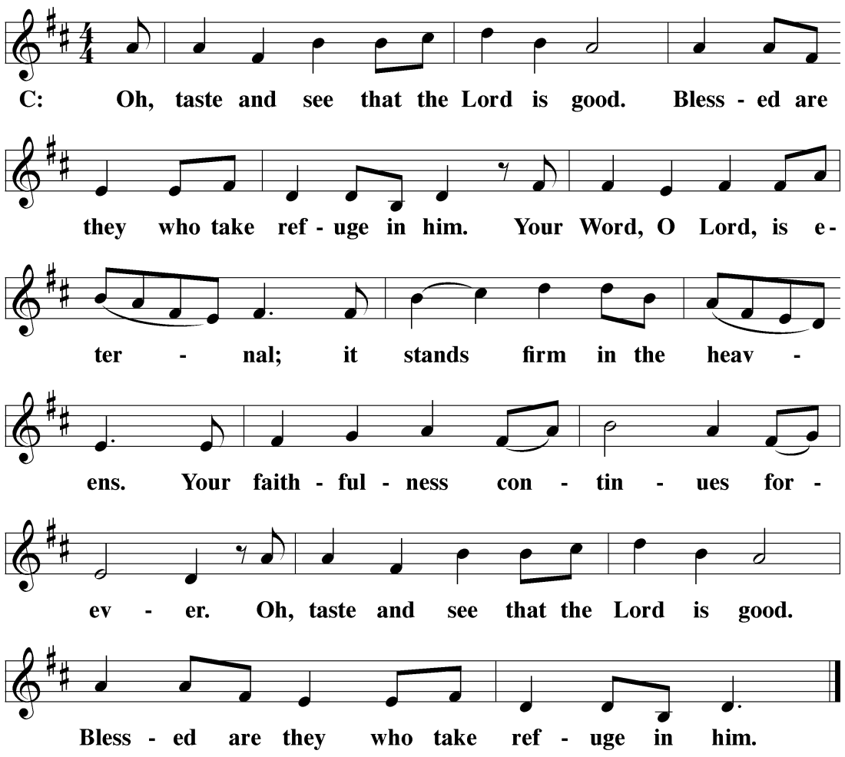

The Service of the Word
Having just received absolution for their sins, believers now gather around the Word of God to find
encouragement and peace for their lives on earth.

PRAYER OF THE DAY
M: Let us pray.
O God, you see that of ourselves we have no strength. By your mighty power defend us from all adversities that may happen to the body and from all evil thoughts that may assault and hurt the soul; through Jesus Christ, Your Son, our Lord, who lives and reigns with you and the Holy Spirit, one God, now and forever.
The Collect (also known as the “Prayer of the Day”) is a concise prayer which “collects” the thoughts of the day and presents them to God in his mercy. Many of these prayers have been in use in the church for more than 1,500 years.

C: Amen

FIRST LESSON Genesis 17:1-7, 15-16
God makes a covenant with Abraham and Sarah. God promises this old couple that they will be the ancestors of nations, though they have no child together. God will bring forth new life from Sarah’s womb.
17 When Abram was ninety-nine years old, the Lord appeared to him, saying, “I am God Almighty. Live^{[a]} in my presence and be blameless. ² I will set up my covenant between me and you, and I will multiply you greatly.”
³ Then Abram fell facedown and God spoke with him: ⁴ “As for me, here is my covenant with you: You will become the father of many nations. ⁵ Your name will no longer be Abram;^{[b]} your name will be Abraham,^{[c]} for I will make you the father of many nations. ⁶ I will make you extremely fruitful and will make nations and kings come from you. ⁷ I will confirm my covenant that is between me and you and your future offspring throughout their generations. It is a permanent covenant to be your God and the God of your offspring after you.
¹⁵ God said to Abraham, “As for your wife Sarai, do not call her Sarai, for Sarah^{[a]} will be her name. ¹⁶ I will bless her; indeed, I will give you a son by her. I will bless her, and she will produce nations; kings of peoples will come from her.”

PSALM OF THE DAY Psalm 73

I am always with you, O LORD;
you hold me by my right hand.
You guide me with you counsel,
and afterward you will take me into glory.
Whom have I in heaven but you?
And earth has nothing I desire besides you.
My flesh and my heart may fail,
but God is the strength of my heart
and my portion forever.
Glory be to the Father and to the Son
and to the Holy Spirit,
as it was in the beginning,
is now, and will be forever, Amen.
Refrain

SECOND LESSON Romans 5:1-11
We’ve been reconciles to him through the New Covenant Christ made with us.
5 Therefore, since we have been justified by faith, we have peace^{[a]} with God through our Lord Jesus Christ. ² We have also obtained access through him by faith^{[b]} into this grace in which we stand, and we boast^{[c]} in the hope of the glory of God. ³ And not only that, but we also boast in our afflictions, because we know that affliction produces endurance, ⁴ endurance produces proven character, and proven character produces hope. ⁵ This hope will not disappoint us, because God’s love has been poured out in our hearts through the Holy Spirit who was given to us.
⁶ For while we were still helpless, at the right time, Christ died for the ungodly. ⁷ For rarely will someone die for a just person—though for a good person perhaps someone might even dare to die. ⁸ But God proves his own love for us in that while we were still sinners, Christ died for us. ⁹ How much more then, since we have now been justified by his blood, will we be saved through him from wrath. ¹⁰ For if, while we were enemies, we were reconciled to God through the death of his Son, then how much more, having been reconciled, will we be saved by his life. ¹¹ And not only that, but we also boast in God through our Lord Jesus Christ, through whom we have now received this reconciliation.

VERSE OF THE DAY Hebrews 12:2
M: [O come, let us fix our eyes on] Jesus, the founder and perfecter of our faith,
C: who for the joy that was set before him endured the cross, despising the shame, and is seated at the right hand of the throne of God.
THE GOSPEL Mark 8:27-38
After Peter confesses that Jesus is the Christ, Jesus tells his disciples for what is to come. Peter’s response indicates that he does not yet understand the way of the cross that Jesus will travel
²⁷ Jesus went out with his disciples to the villages of Caesarea Philippi. And on the road he asked his disciples, “Who do people say that I am?”
²⁸ They answered him, “John the Baptist; others, Elijah; still others, one of the prophets.”
²⁹ “But you,” he asked them, “who do you say that I am?”
Peter answered him, “You are the Messiah.” ³⁰ And he strictly warned them to tell no one about him.
³¹ Then he began to teach them that it was necessary for the Son of Man to suffer many things and be rejected by the elders, chief priests, and scribes, be killed, and rise after three days. ³² He spoke openly about this. Peter took him aside and began to rebuke him. ³³ But turning around and looking at his disciples, he rebuked Peter and said, “Get behind me, Satan! You are not thinking about God’s concerns^{[a]} but human concerns.”
³⁴ Calling the crowd along with his disciples, he said to them, “If anyone wants to follow after me, let him deny himself, take up his cross, and follow me. ³⁵ For whoever wants to save his life will lose it, but whoever loses his life because of me and the gospel will save it. ³⁶ For what does it benefit someone to gain the whole world and yet lose his life? ³⁷ What can anyone give in exchange for his life? ³⁸ For whoever is ashamed of me and my words in this adulterous and sinful generation, the Son of Man will also be ashamed of him when he comes in the glory of his Father with the holy angels.”

M: This is the Gospel of the Lord.
C: Praise be to you, O Christ!

HYMN OF THE DAY A Lamb Goes Uncomplaining Forth| CW 100
SERMON Genesis 17:1-7,15-16
APOSTLES’ CREED
I believe in God, the Father almighty, 2 Cor. 6:18
Upon hearing the Word preached, the congregation unites in one voice to speak a summary of the Christian faith that all Christians profess. The creeds signify our allegiance to the Christian faith and unite us with over 2,000 years of Christian history. By repeating the creeds weekly, we equip ourselves for public witness by grounding our confession in the fundamentals of our faith.
maker of heaven and earth. Is. 51:13
I believe in Jesus Christ, his only Son, our Lord, 1 Cor. 8:6; Jn. 3:18
who was conceived by the Holy Spirit, Lk. 1:35
born of the virgin Mary, Lk. 1:34; 2:7
suffered under Pontius Pilate, Lk. 23:16
was crucified, died, Mt. 27:32-61; Mk 15:21-47
and was buried. Lk. 23:26-56; Jn. 19:16b-42
He descended into hell. 1 Pet. 3:19
The third day he rose again from the dead. 1 Cor. 15:4b
He ascended into heaven Ac. 2:33-34
and is seated at the right hand
of God the Father almighty. Heb. 1:13
From there he will come to judge Mt. 25:31
the living and the dead. 2 Tim. 4:1
I believe in the Holy Spirit, Mt. 3:16-17
the holy Christian Church, Eph. 5:23
the communion of saints, Eph. 4:3-6
the forgiveness of sins, Rom. 4:6-8
the resurrection of the body, 1 Cor. 15:13-19
and the life everlasting. Amen. 1 Th. 4:17

OFFERING
Of all the gifts God gives to us, forgiveness in Jesus Christ is the most precious. No gift we could give back to God for what he did through his Son Jesus Christ could ever balance the debt we owe for what our Lord accomplished for us on the cross. Yet Jesus says the debt we owe has been canceled, that means that we do not give out of obligation but as an act of worship and thanks to God. The offerings of the members of Christ Lutheran are gathered at this time. Guests need not feel obligated to give an offering.

PRAYER OF THE CHURCH
M: Heavenly Father, you loved the world and gave your Son to liberate us from sin and death by his obedient death on the cross.
C: We confess that without your love we are lost.
M: Lord of the Church, we thank you for the treasure of the gospel. By your Spirit, keep our eyes fixed on Jesus, the author and perfecter of our faith.
C: Strengthen our determination to do what pleases you, no matter what the danger or the cost.
M: Let us pray for those who carry a cross in the name of Christ and face ridicule and persecution for the sake of the kingdom: missionaries and chaplains, young people who stand up for what is right in the face of pressure to do what is wrong, and all who pay a high price for their faith and their values as Christians.
C: By your Spirit, O Lord, grant them patience and endurance.
M: Let us pray for those who carry heavy burdens in life: the sick and the chronically ill, the depressed and the lonely, those torn by conflict in personal relationships, those victimized by war and injustice, and all who face the terrors of life with a heavy heart.
C: Grant them peace, O Lord, and in your mercy, be their guardian and friend, their comfort and hope.
M: Let us pray for those who care for others: pastors and counselors; physicians and nurses; social workers and caring friends; all who feed the hungry, comfort the hurting, and stand beside the dying.
C: Strengthen them in their work, O Lord, and do not let them become weary in doing good.
Special prayers and intercessions.
M: Hear us, Lord, as we bring you our private petitions.
Silent Prayer.
M: Help us run with perseverance the race marked out for us. Keep us faithful even to the point of death, that we may receive the crown of life, through Jesus Christ, our Lord.
C: Amen.
LORD’S PRAYER
Our Father, who art in heaven,
hallowed be thy name.
Thy kingdom come.
Thy will be done,
on earth as it is in heaven.
Give us this day our daily bread;
and forgive us our trespasses,
as we forgive those
who trespass against us;
and lead us not into temptation,
but deliver us from evil.
For thine is the kingdom
and the power and the glory
forever and ever. Amen.

HYMN Not All the Blood of Beasts | CW 128

PRAYER
M: O Lord God, our heavenly Father, pour out the Holy Spirit on your faithful people. Keep us strong in your grace and truth, protect and comfort us in all temptation, and bestow on us your saving peace, through Jesus Christ, our Lord, who lives and reigns with you and the Holy Spirit, one God, now and forever.
C: Amen.
THE BLESSING Numbers 6:22-27
The blessing of Aaron has been spoken over God’s people for 3,500 years. The Lord said, “So I will put my name on them, and I will bless them.”
M: Brothers and sisters, go in peace. Live in harmony with one another. Serve the Lord with gladness.
M: The Lord bless you and keep you.
The Lord make his face shine on you and be gracious to you.
The Lord look on you with favor and ✙ give you peace.
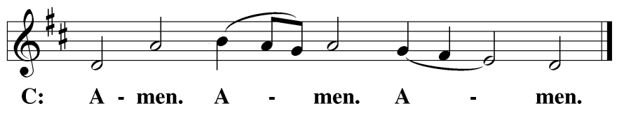
Be seated

CLOSING HYMN When Peace Like a River | CWS 760
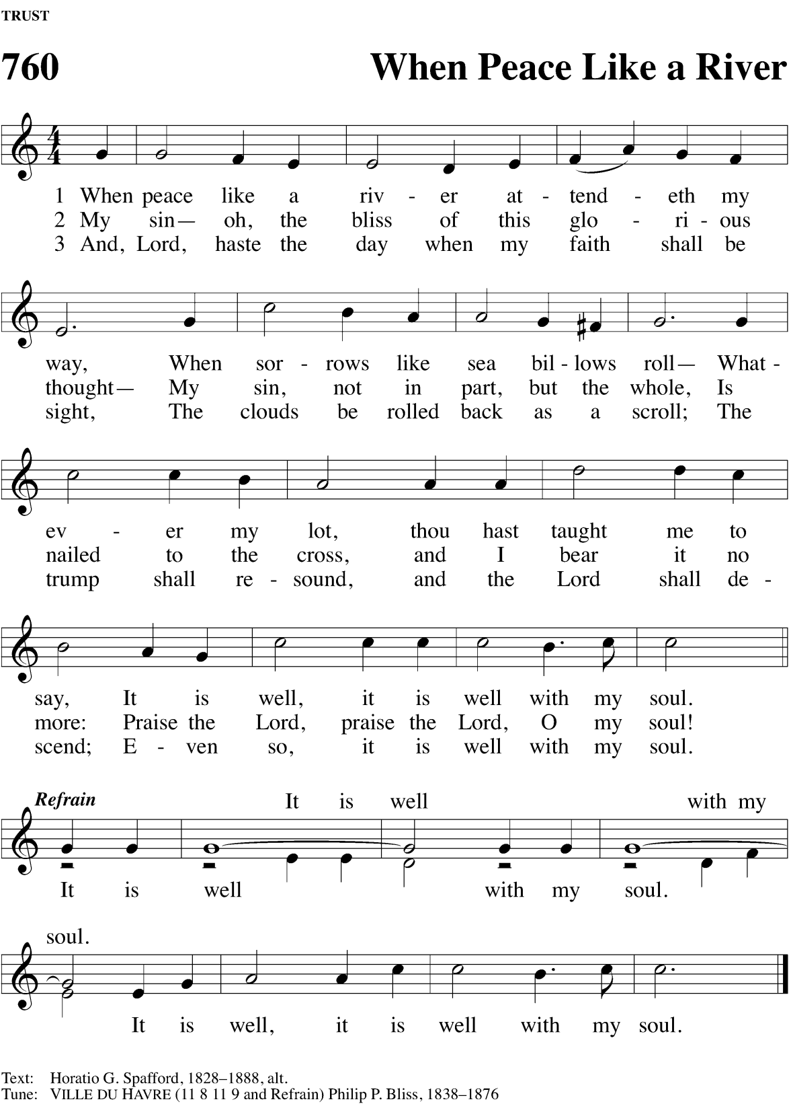
COPYRIGHT INFORMATION
Content requiring a copyright license is reproduced under OneLicense.net #A-718312. All rights reserved. The Common Service: Texts revised from The Lutheran Hymnal, 1941. Music revised by James Engel. Scripture Quotations: From the Holy Bible, New International Version (NIV 1984), © 1973, 1978, 1984 by Biblica, Inc.

Projects where we need help
- Ladies Bathroom needs light repaired. IT IS FINISHED! Thank you.
- Back of Church needs weeded.
- Litter patrol frontage.
- Back Sweet Olive line needs to be weeded.
- Sprinklers need to be replaced with drip line.
- Lawn mower repair and maintenance (oil changes, blade sharpening).
- Trim trees and shred material.
- Wash AC coils.

Thank you very mulch!
- Plastic laid down and wood chips placed around play structure.

This Lent, we will use the metaphor of eyesight to examine how the various people in Mark’s Gospel viewed Jesus during His Passion. In most cases, they misunderstood who He was and what He was doing; then again, sometimes by faith people did recognize Him correctly.

We have these forty days of Lent in which we may look within ourselves as people of faith in our day. How are we like or unlike the people who saw Jesus in the flesh? Most important, as we gather for worship, we will see what Jesus has done to save us from our sins by His holy, precious blood and innocent sufferings and death.

Today, we see in Gethsemane that Jesus’ inner circle—Peter, James, and John—cannot keep their eyes open to watch and pray with Him for even an hour. How awake have we been, lest we fall prey to temptation? Why does Jesus agree that His Father’s will be done?

Lent 2
Sleepy Eyes
Mark 14:32-42
Lent 3
Denying Eyes
Mark 14:26-31,66-72
Lent 4
Murderous Eyes
Mark 14:1-2, 53-65
Lent 5
Worldly Eyes
Mark 15:1-20
Holy Thursday
More Than Meets the Eye
Mark 14:22-25
Good Friday
God’s Eyes
Mark 15:21-39

Easter Vigil
Resting Eyes
Mark 15:40-16:1
Easter
Angel Eyes
Mark 16:1-8

